Where does your family’s history meet the history of the Essex County Park System?
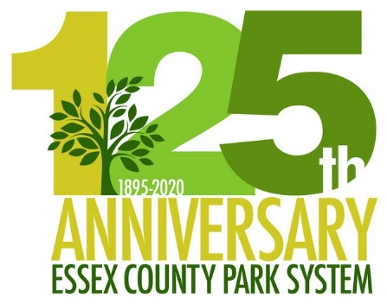
Do you have old photos taken by your family in any of the Essex County parks? The Parks Archives would enjoy seeing them to celebrate the rich and extensive history of the Essex County Park System, the first county park system in the United States.

We would also love to hear stories of how generations of your family have experienced any of the parks, reservations, and other facilities of the Park System. Was a park your backyard? The place you held family picnics? Where your father played ball? Where your grandparents met?

We hope to gather many old photographs and stories from those who have treasured memories of our outdoor spaces. Assist with the celebration by sharing your family’s memories today!

Digital images and written stories may be sent, along with the photo release below, to archives@parks.essexcountynj.org . If you have non-digital photos to share, but are unwilling to part with the original, email or call 973-735-6230 to make arrangements.

MEMORIES GROW IN OUR PARKS!
- - - - - - - - - - - - - - - - - - - - - - - - - - - - - - - - - - - - - - - - - - - - - - - - - - - - - - - - - - - - - - - - - - - - - -

PHOTOGRAPHY COPYRIGHT RELEASE

To: Archives Date: _________________
County of Essex
Department of Parks, Recreation, & Cultural Affairs
115 Clifton Avenue
Newark, NJ 07104

I, ________________________, am the owner and copyright holder of the photo/image(s) described as:

________________________________________________________________________

________________________________________________________________________

________________________________________________________________________
[Photo(s) / Image(s) Description]

I hereby grant you the right of possession of the above-described image(s) / photo(s) shot by me and have my permission to make unlimited printed or developed photographs, for your use.

If you should have any questions regarding the authenticity of this document or the terms herewith, please contact me.

Signature __________________________ Print Name _____________________

Address ____________________________ _______________________________

